Write by the Beach 2018: from inspiration to publication with the Beach Hut Writing Academy
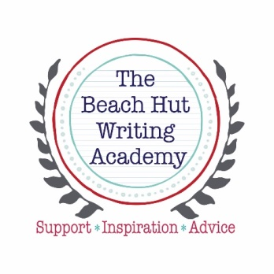

9.30 | Welcome by your hosts, Kate Harrison & Laura Wilkinson
9.40-  10.40 | Plotting with Post-its… with bestselling author and creative writing teacher, Julie Cohen.
 | Academy Alternatives: pick one
10.45-  11.45 | Option A: Pitch Clinic with Kate Harrison | Option B: YA with Sarah Crossan, Julia Churchill & Nikki Sheehan
11:45-12.10 | Tea & Coffee Café (Ground Floor)
12.15  1.15 | The agents’ secrets: a panel of top agents tell you how to catch their eye with a standout submission & what they’re looking for now.
1.15-2.15 | Networking Buffet Lunch (Café)
2.15-3.15 | Keynote: The Psychological Thriller: from Great Expectations to Gone Girl – why it’s nothing new and where it’s going next with Erin Kelly
3.30-5.30 | Agent/Commissioning Editor one to ones
3.15-4.15 | Academy Alternatives: pick one
 | Option A: Short Stories with Erinna Mettler |  | Option B: Memoir with Bridget Whelan
4.15-4.40 | Tea & Coffee Café (Ground Floor)
4.45-5.45 | Panel: AUTHOR:COMM EDITOR TALK – Elizabeth Enfield, Erinna Mettler, Sarah Rayner, Araminta Hall with 2 Commissioning Editors
5.45 - 6.15 | Best Pitch Competition – Judged by David Headley of DHH Literary Agency & Goldsboro Books

